**Jenkins**

**CI/CD(Continuous Integration and Continuous Deployment)**

Continuous Integration is the practice of testing each change done to your codebase automatically and as early as possible. Continuous Deployment follows the testing that happens during Continuous Integration and pushes changes to a staging or production system.

**Jobs**

Jobs are the heart of Jenkins's build process. A job can be considered as **a particular task to achieve a required objective in Jenkins**. Build is a historical context of project deployment or development process.

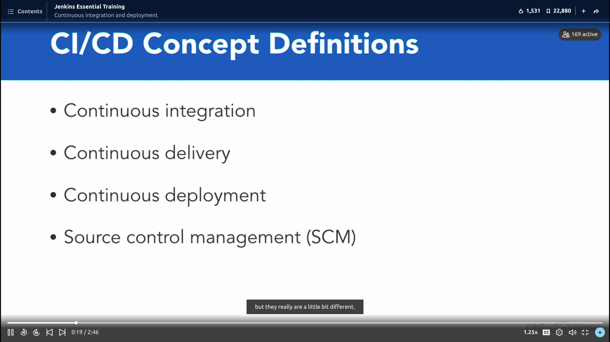

Developing +Testing → CI

CI + Staging→CD

CD+ Production →Continuous Deployment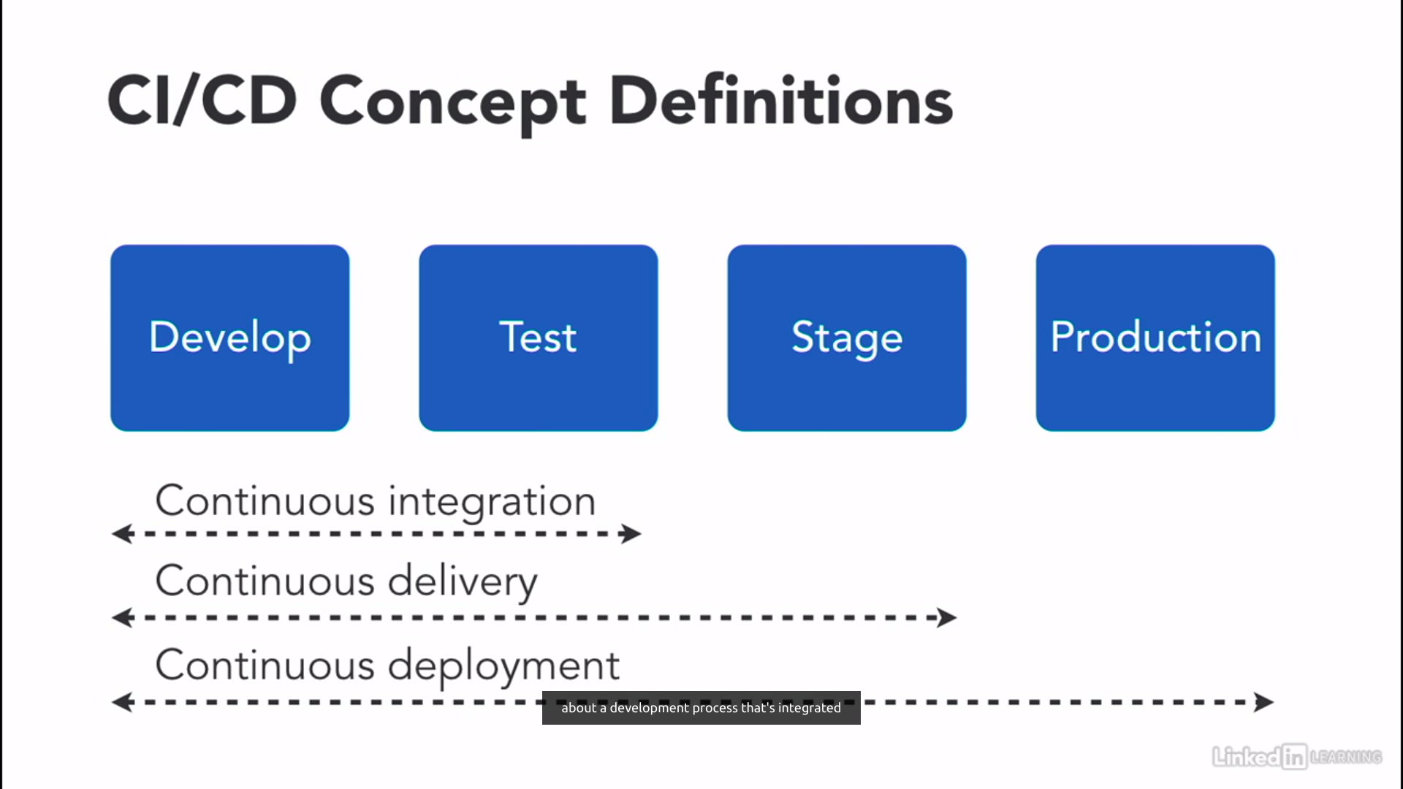

**Benefits For CI/CD**

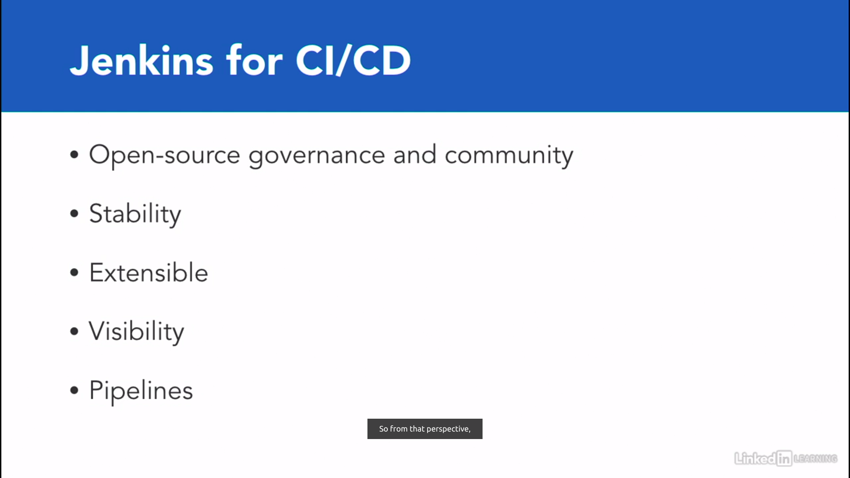

These are the steps for application process.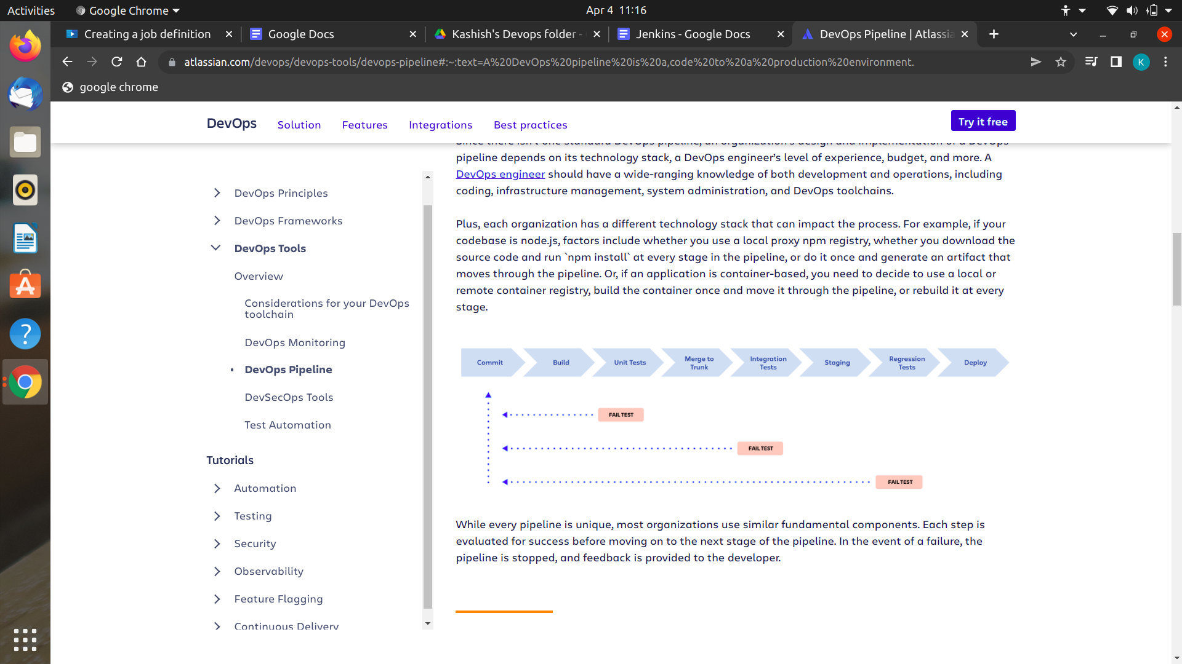

**JOBS**

We can make any project and can build it.

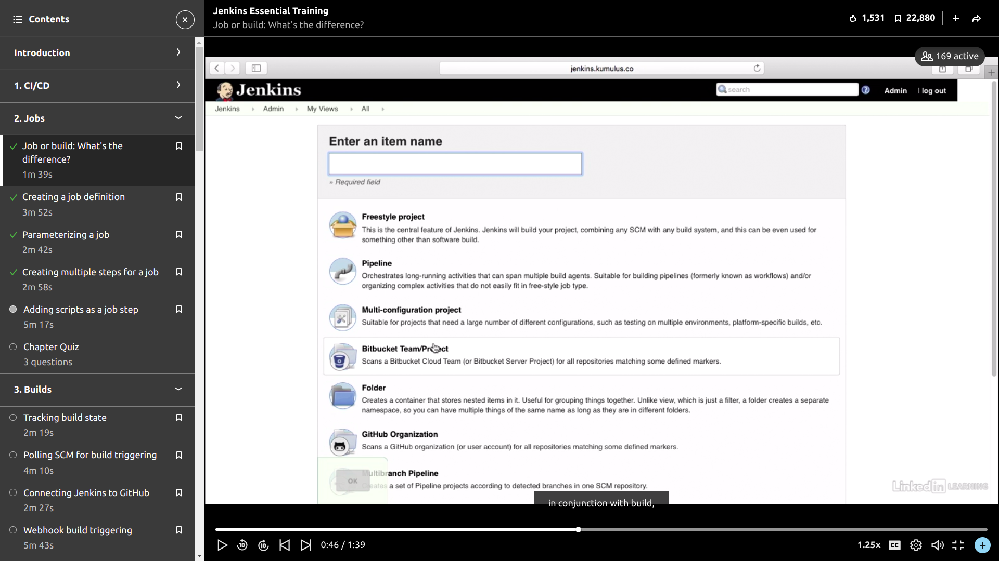

Here ‘s the pipeline syntax of jenkins file..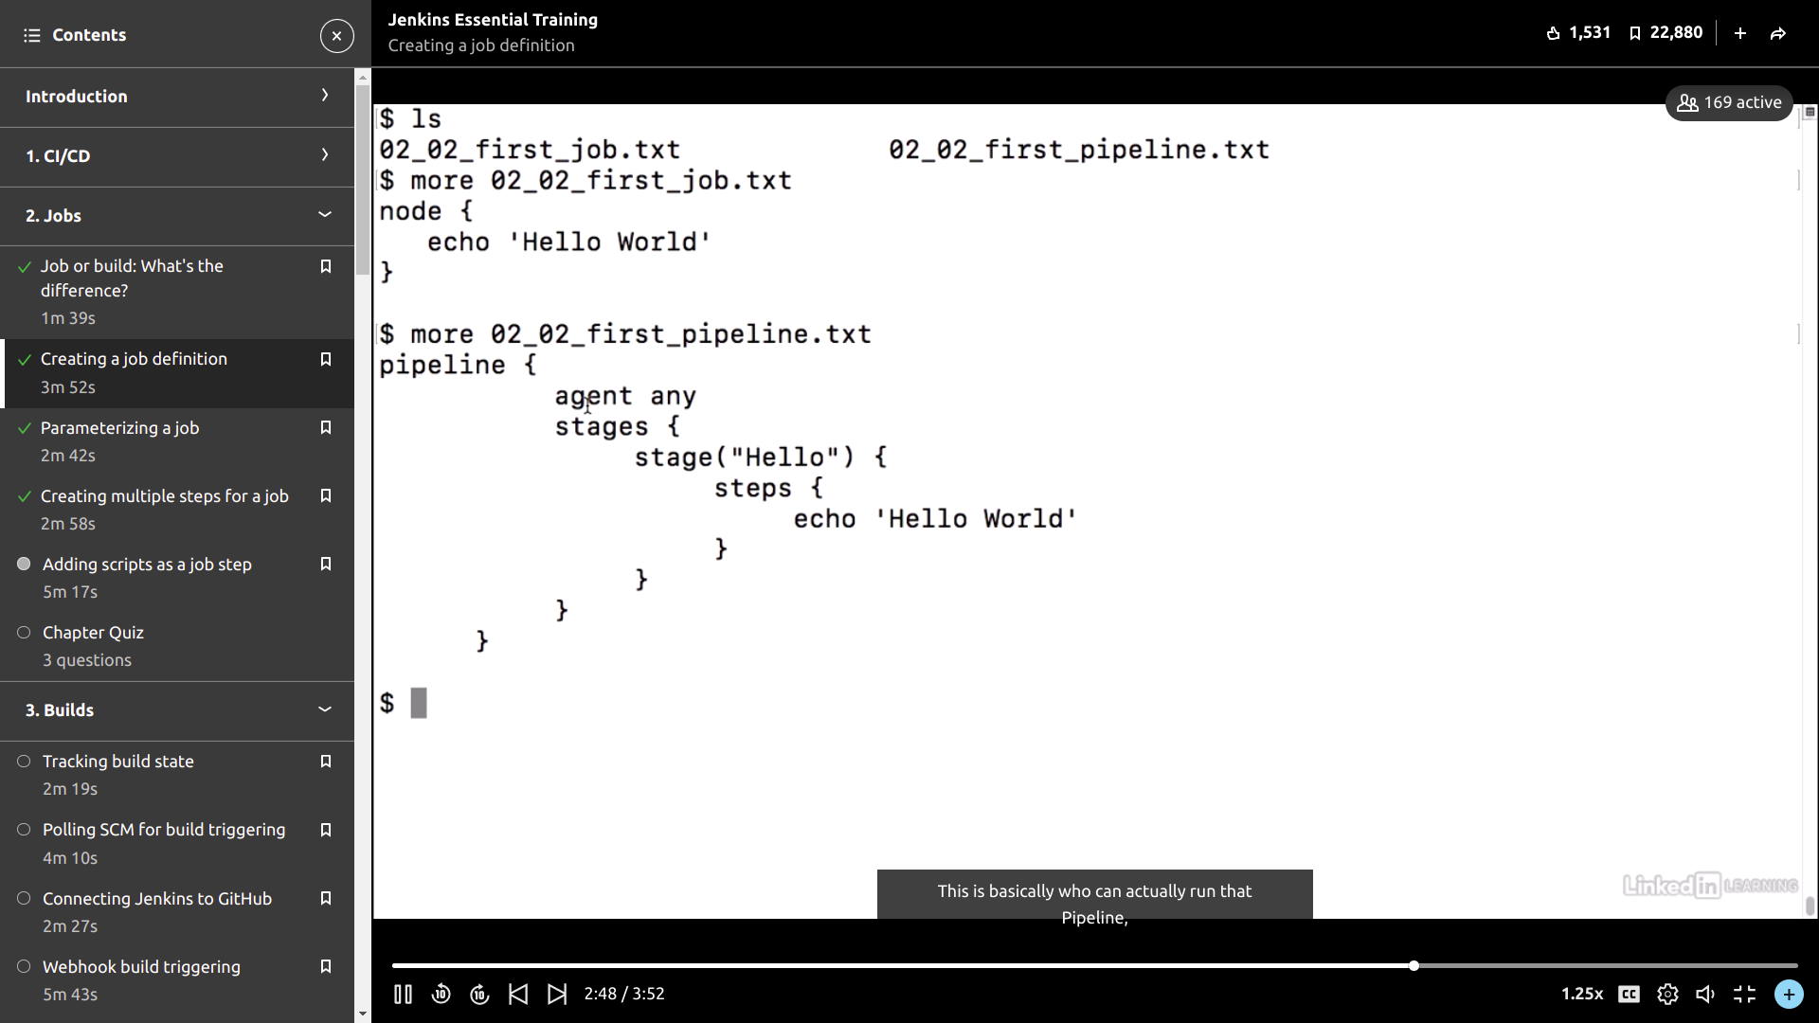

Jenkins file created on github.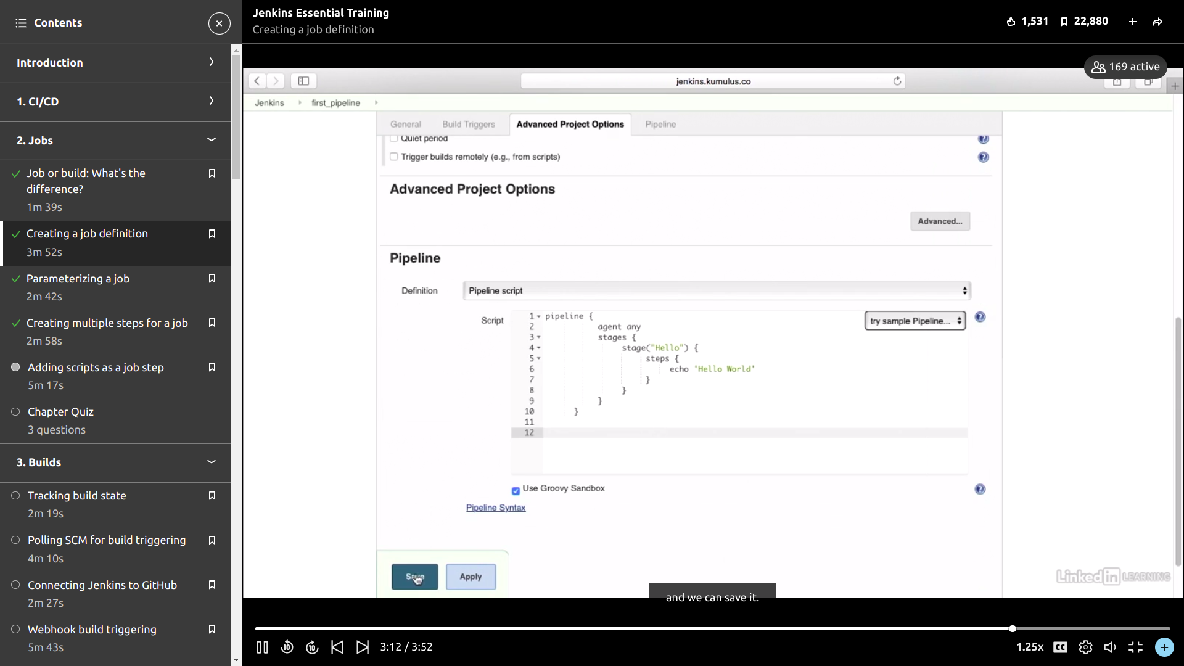

Scanned and built the files to track.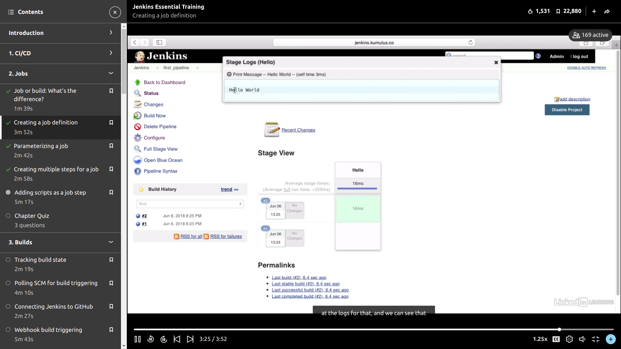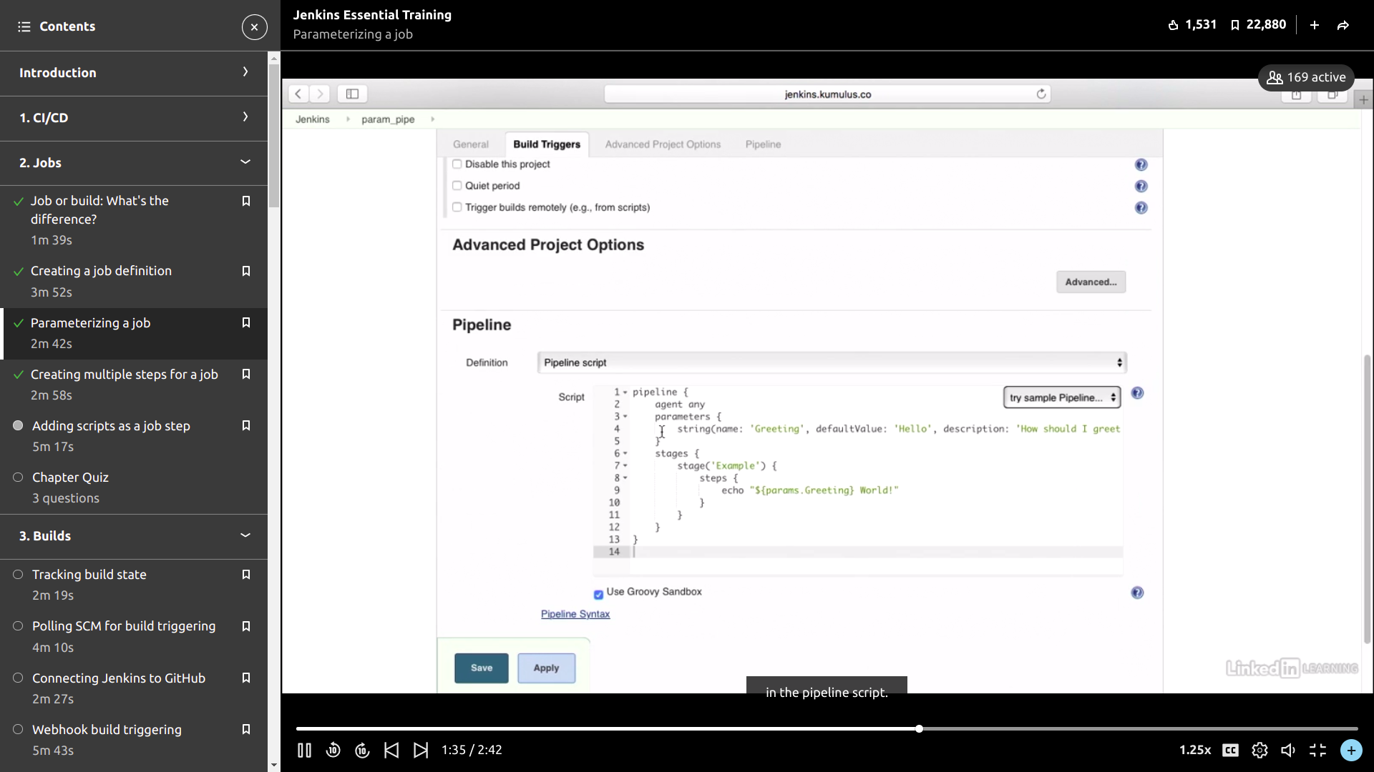

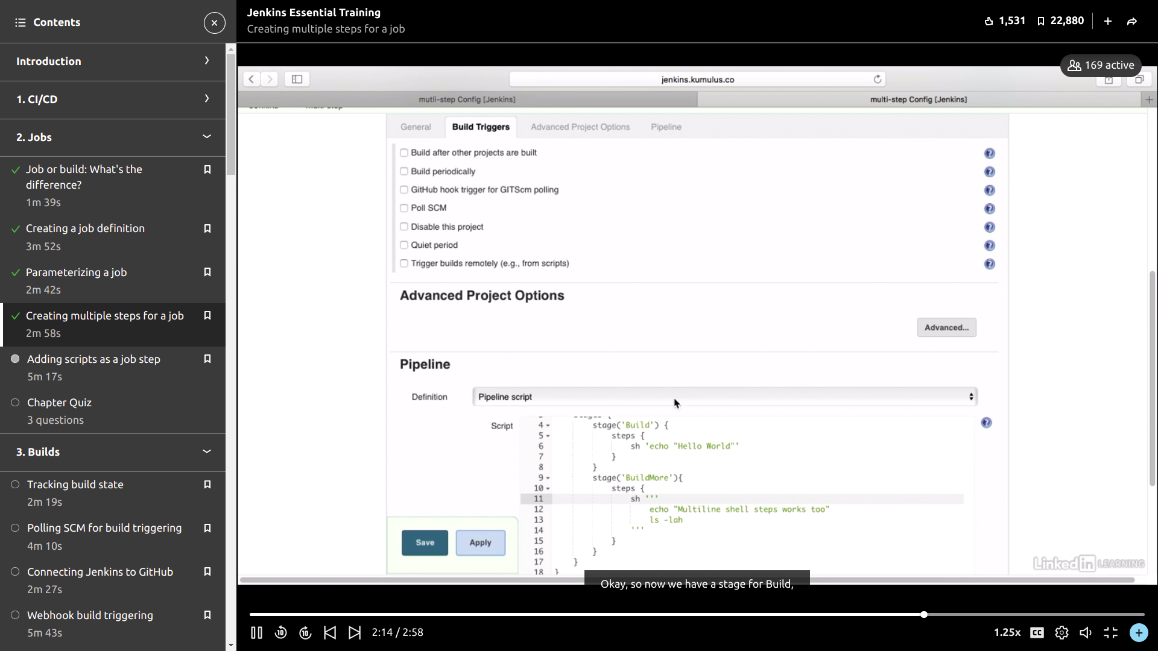

Built the project and staged.

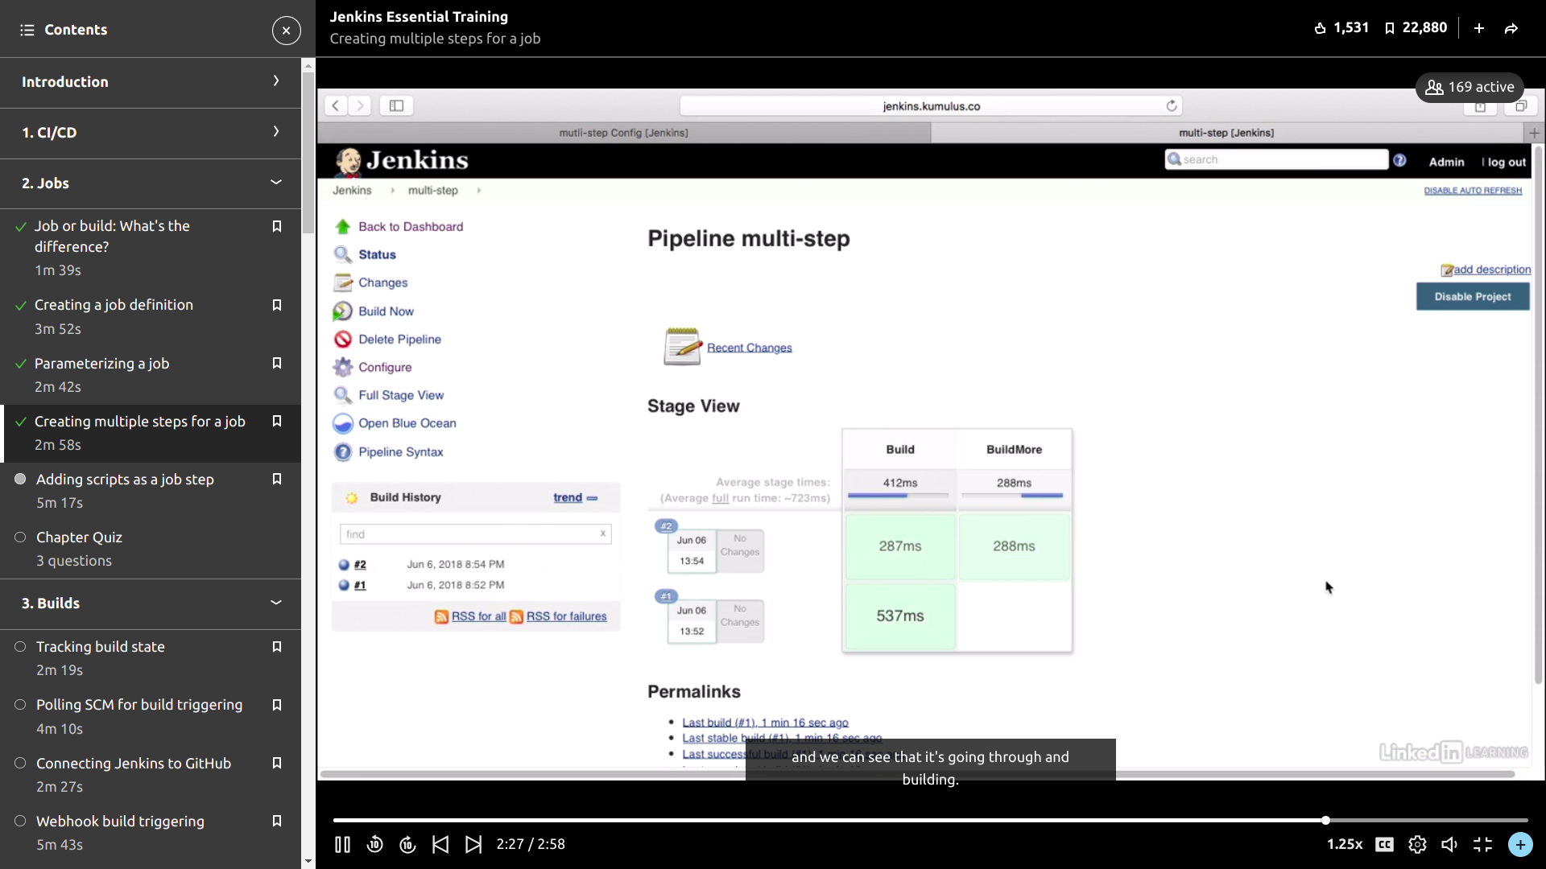

Connecting the git Repository.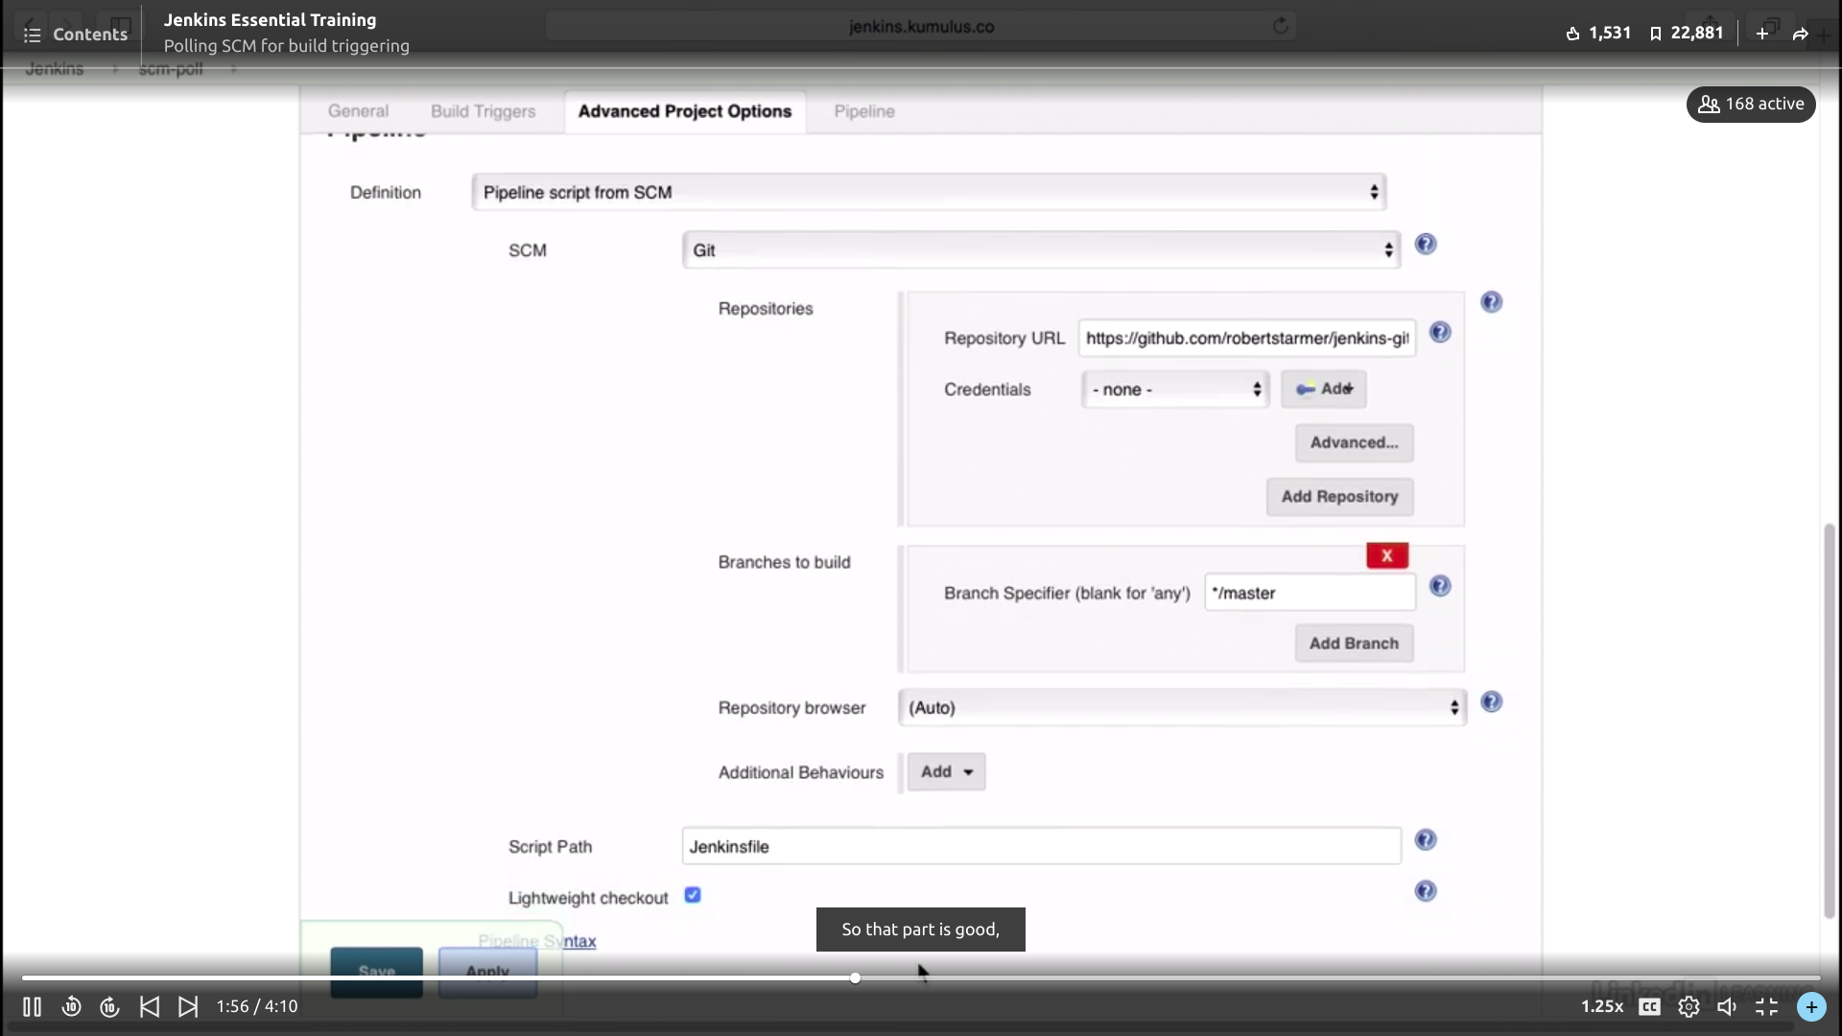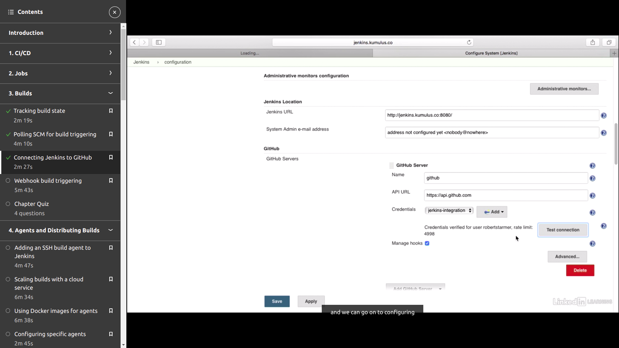

It scans the repository to check if there’s no error.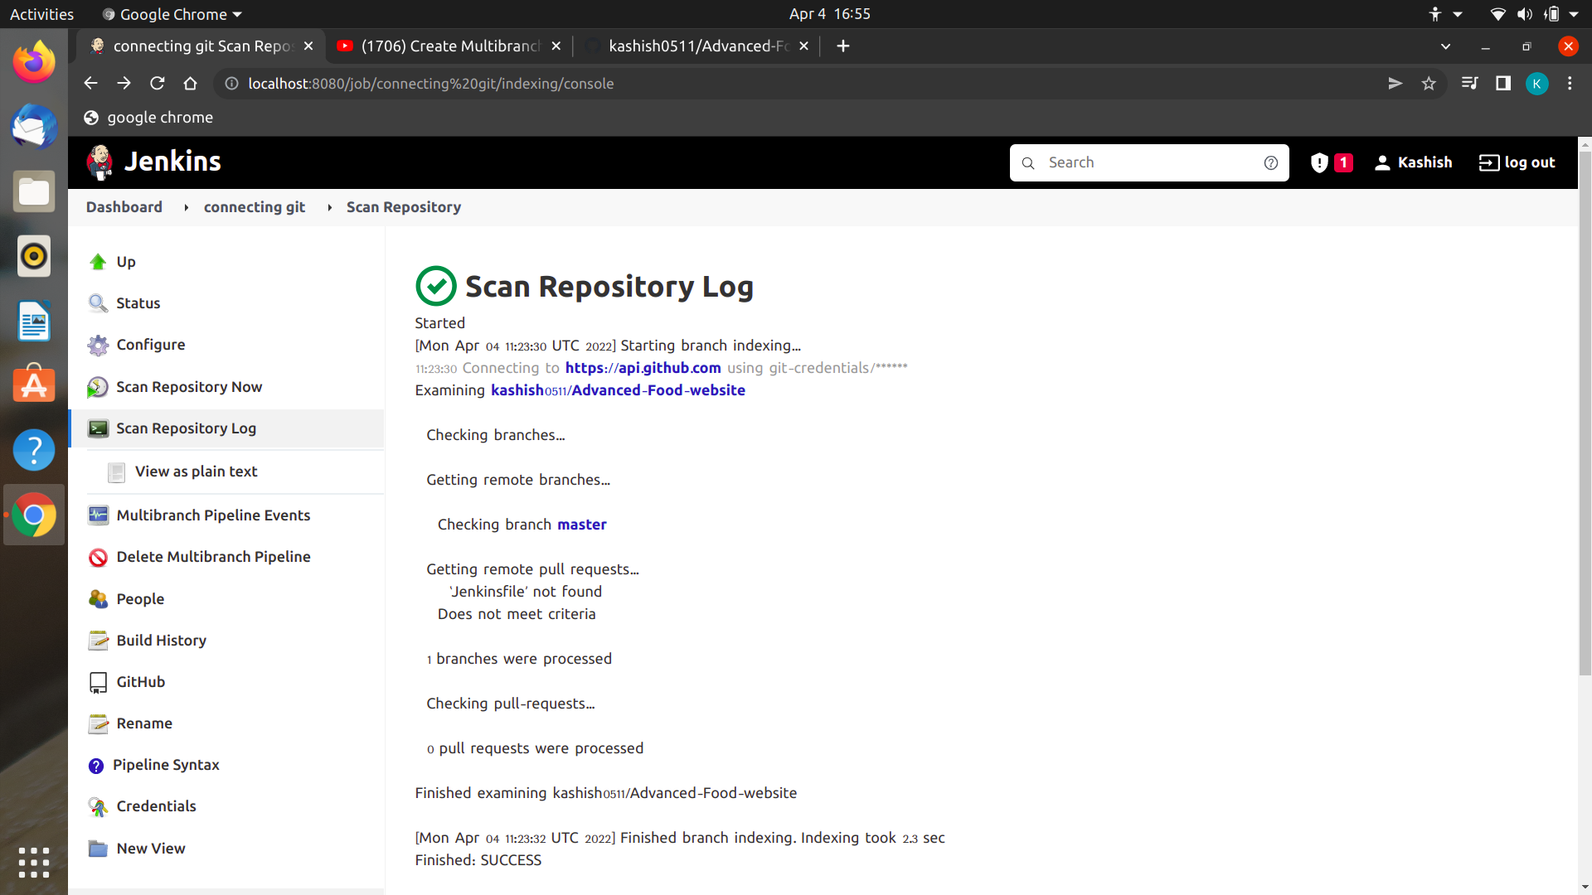

Created a multipipeline branch and free styleproject. And built.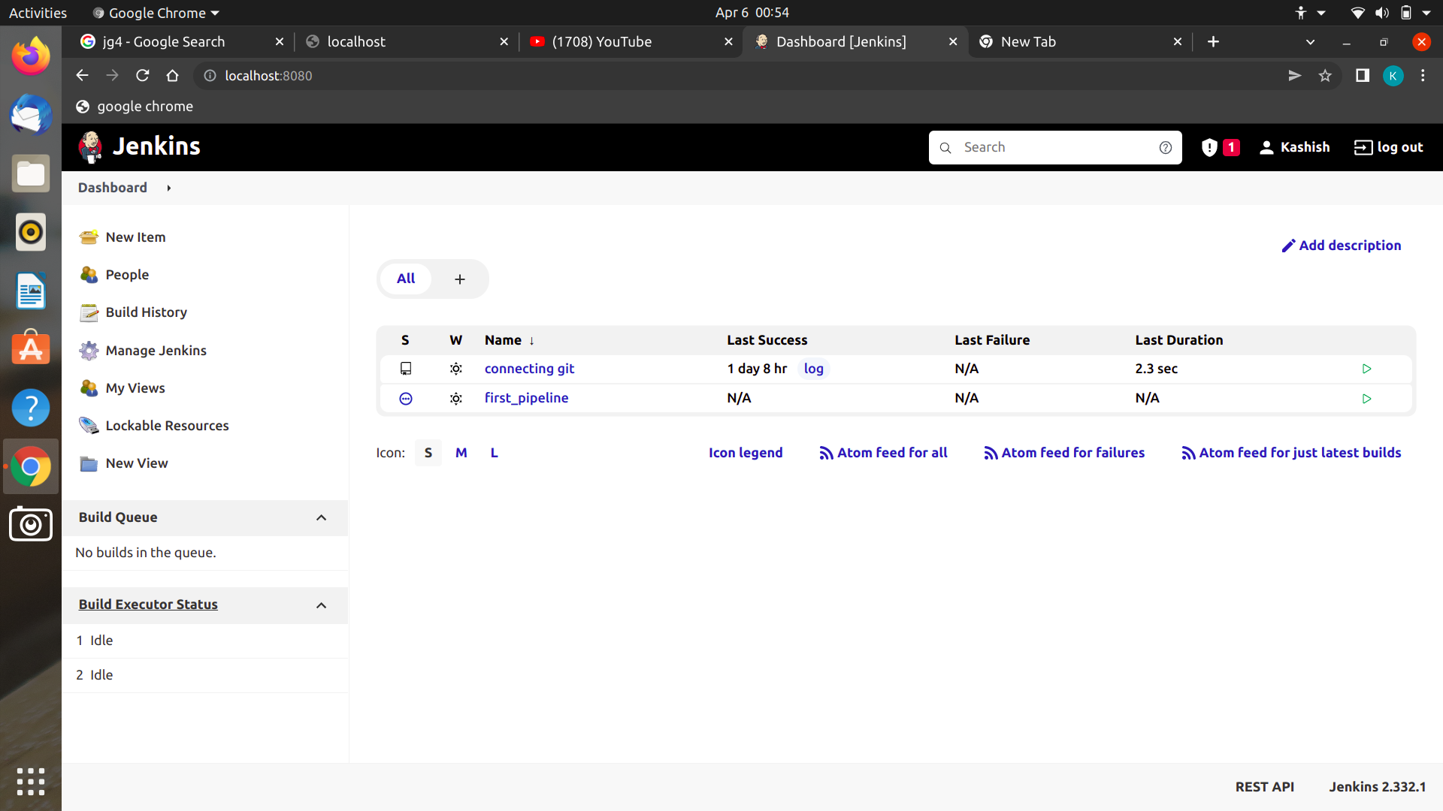

**Scripted and Declarative**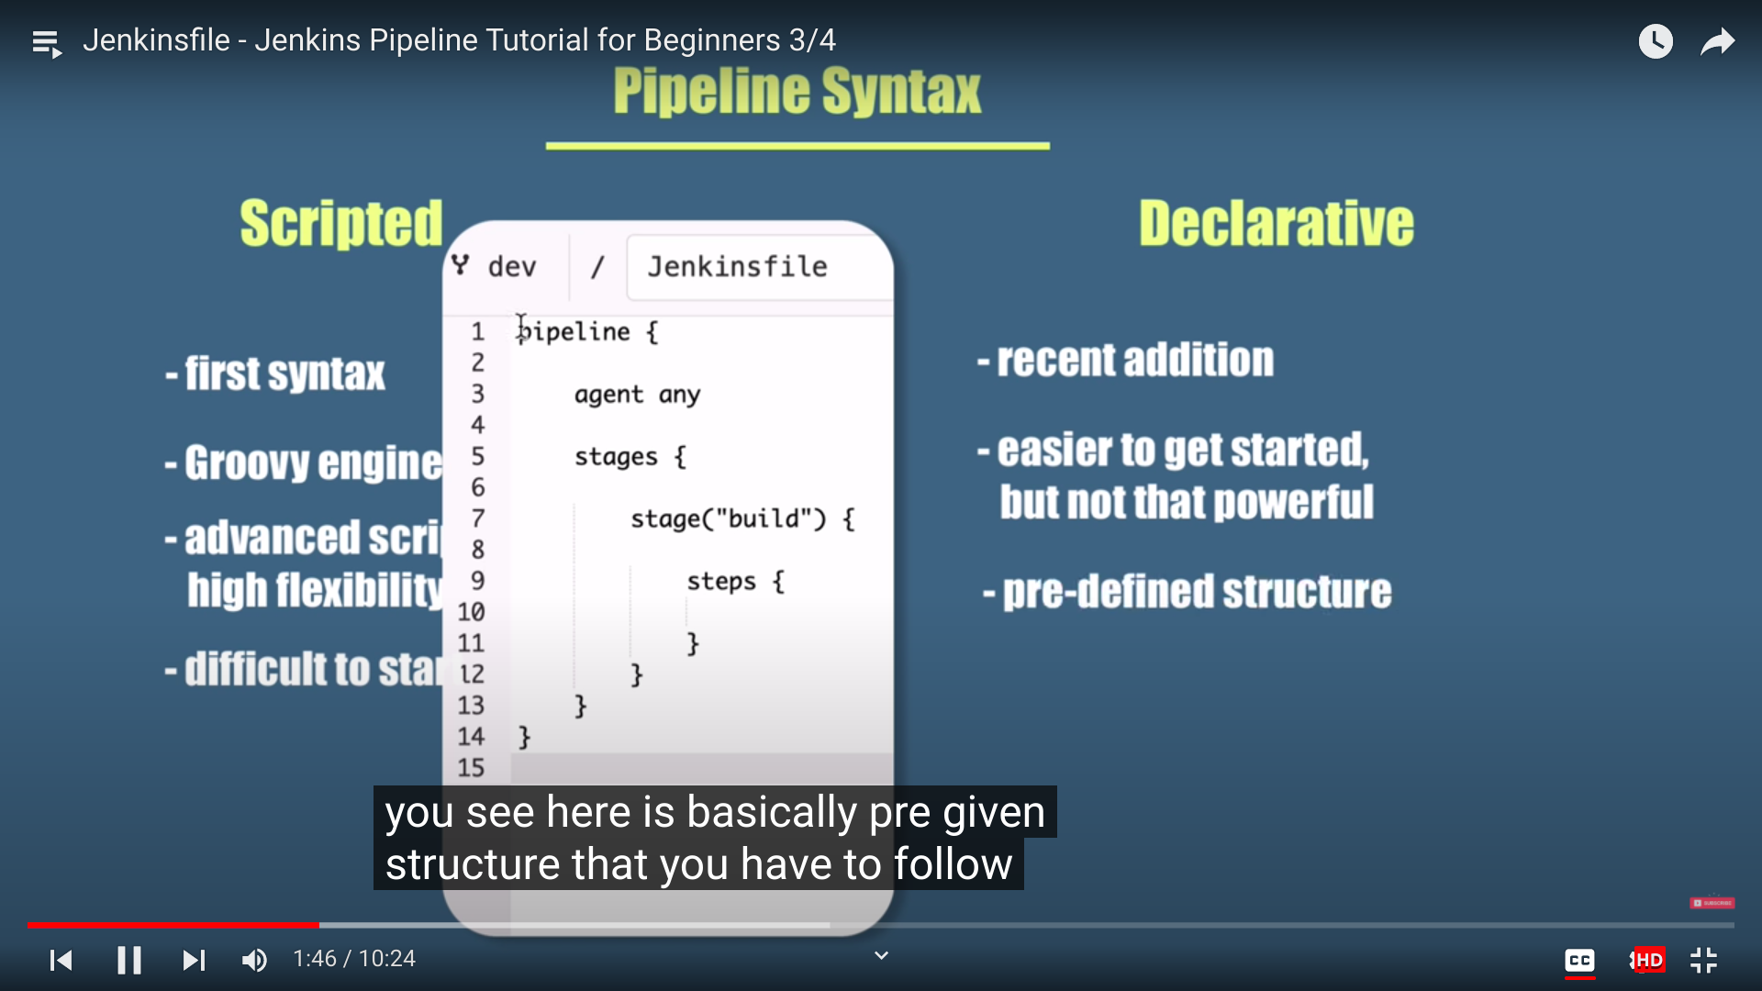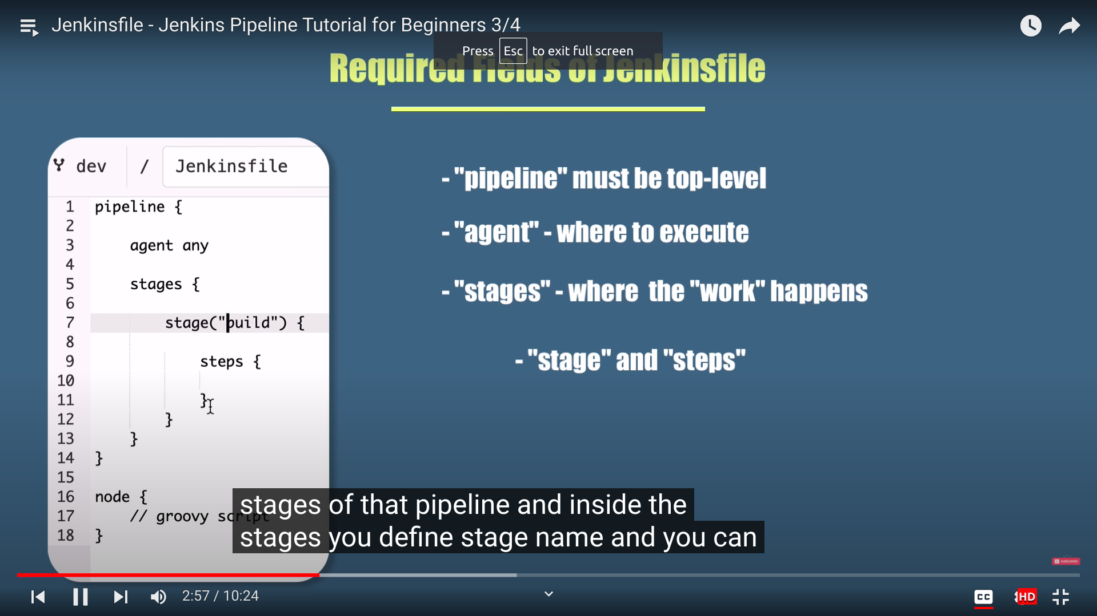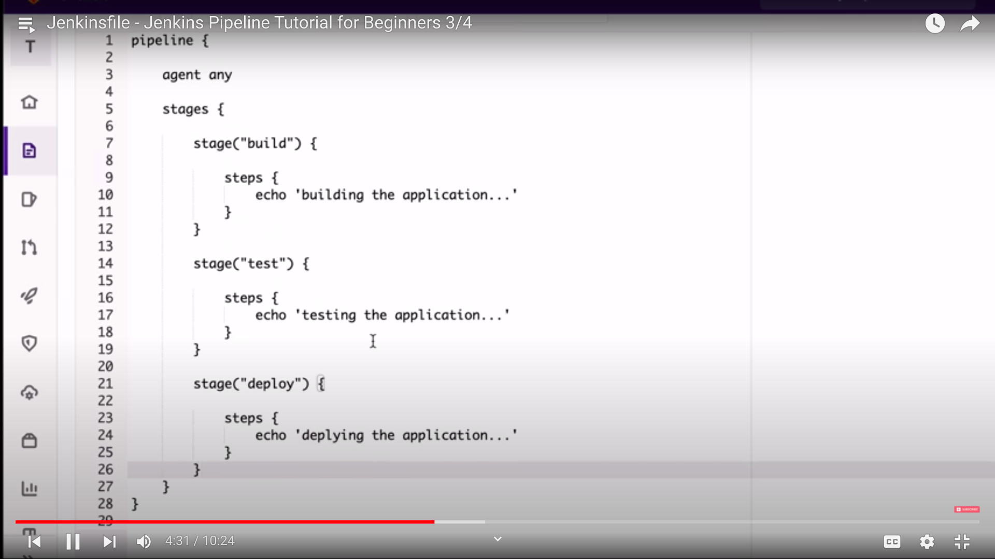

Can change the built pipelines if committing errors.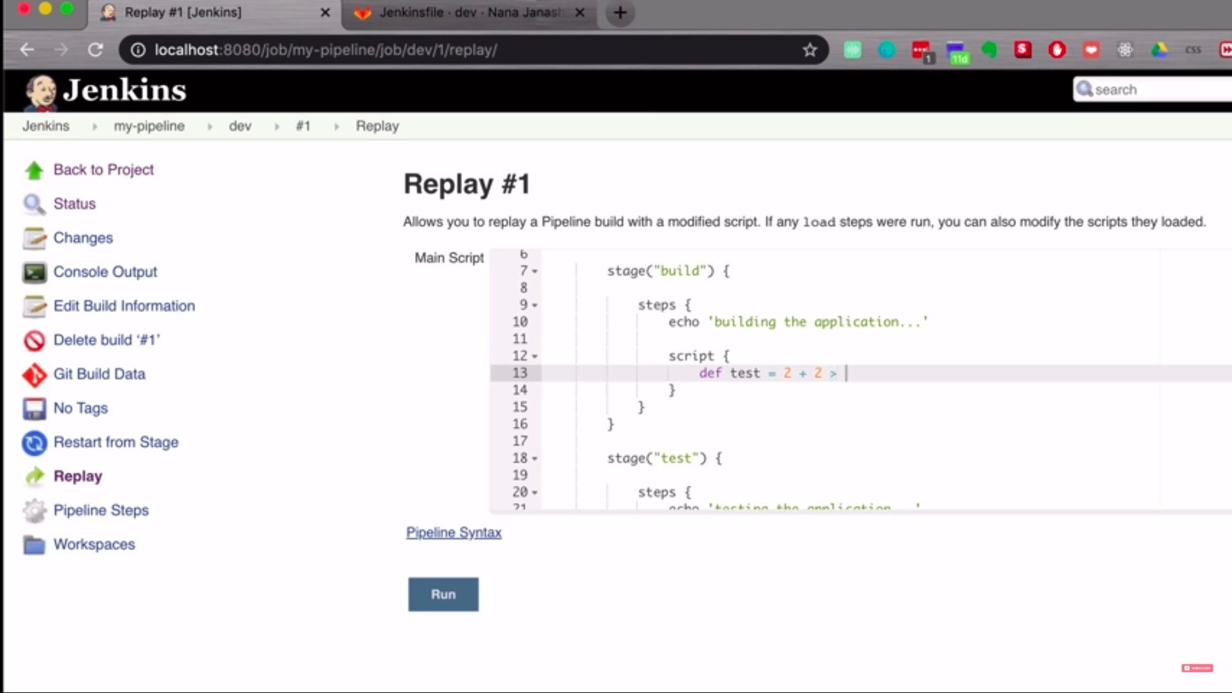

**Trigger Build**

Developer make changes to the code which is being committed to git repository and which is being pushed to jenkins.

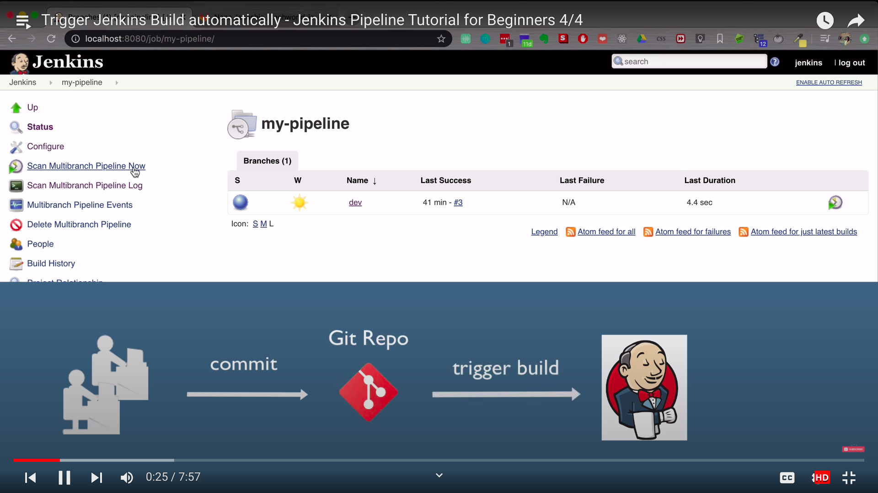

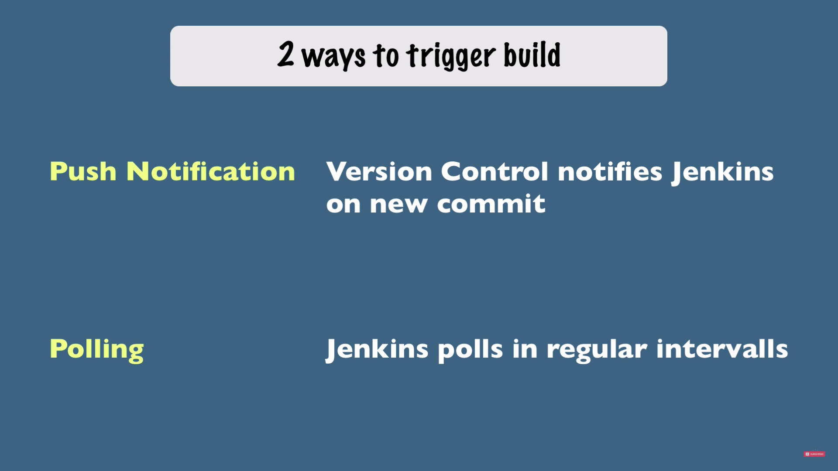

It automatically tests the commit which is been made to git repository by every interval of time.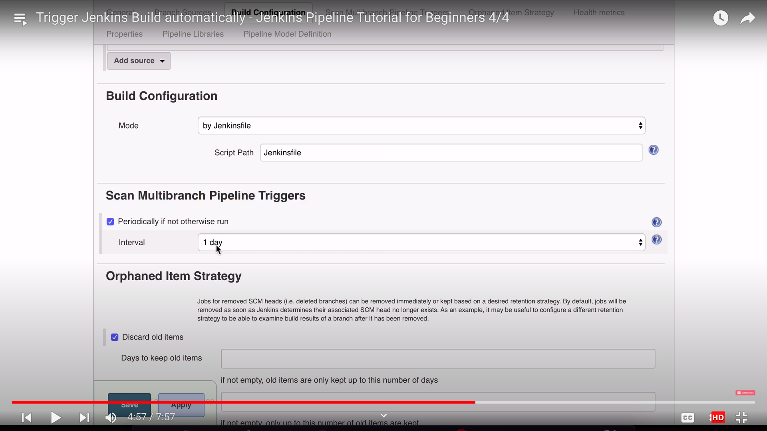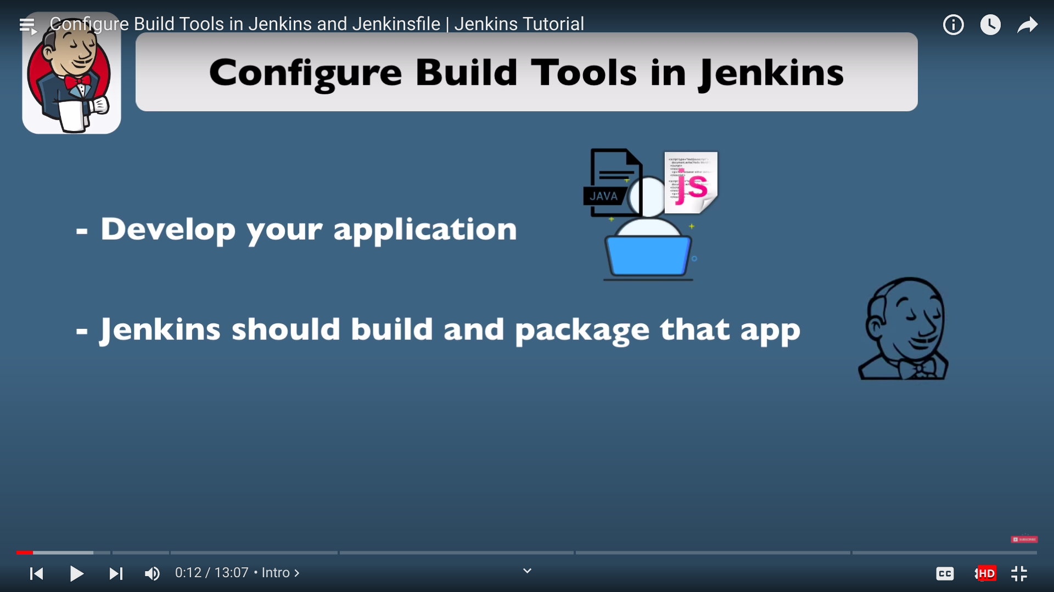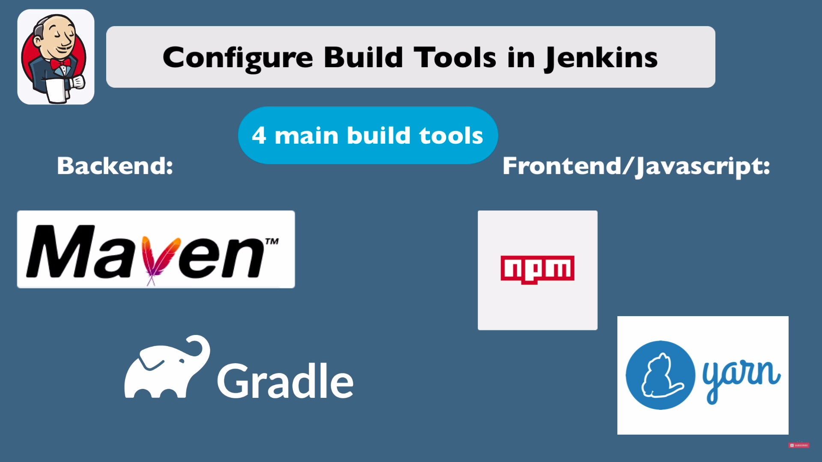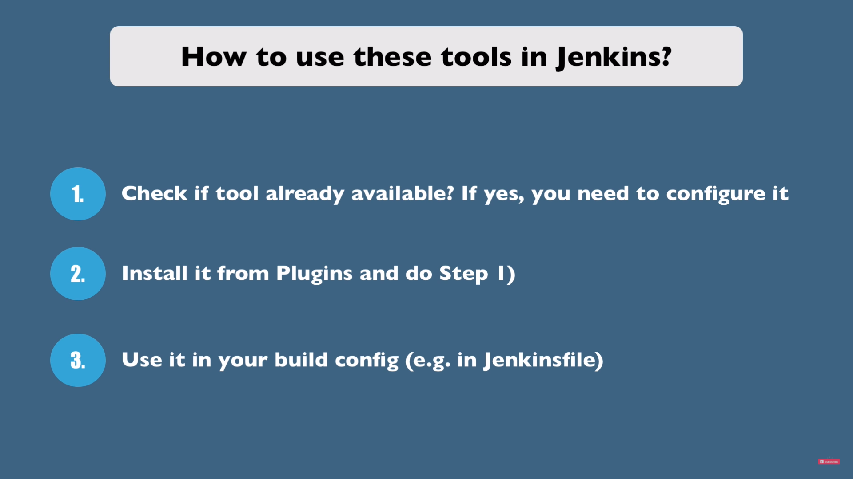

Add tools which automatically get installed by setting up in jenkins.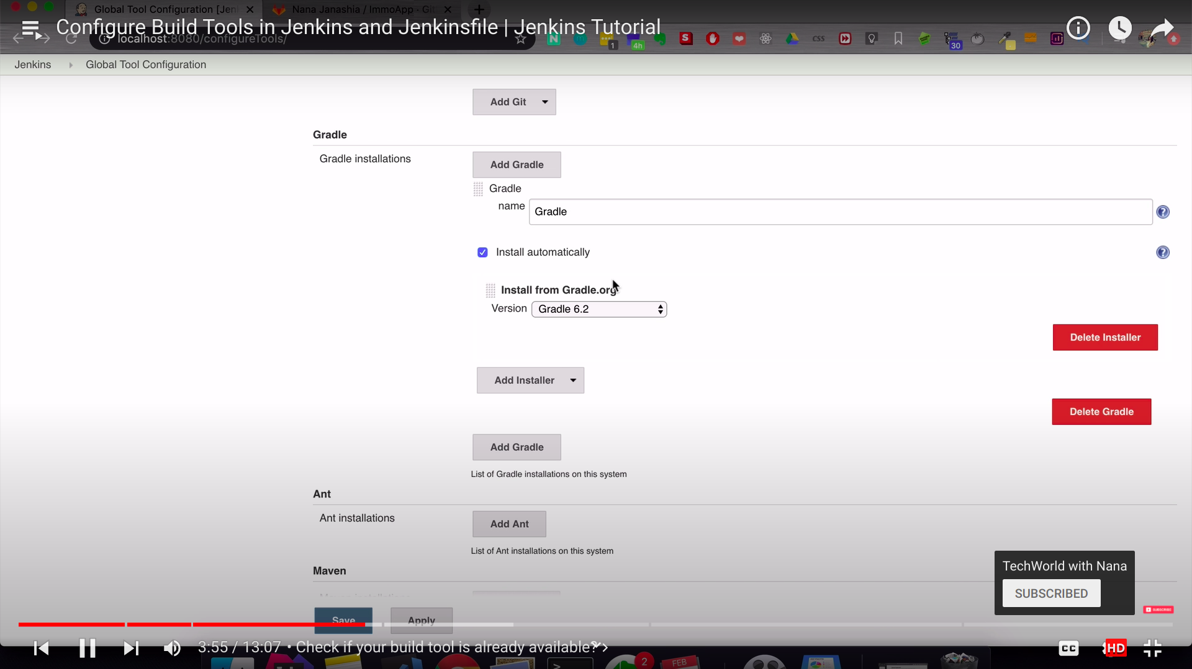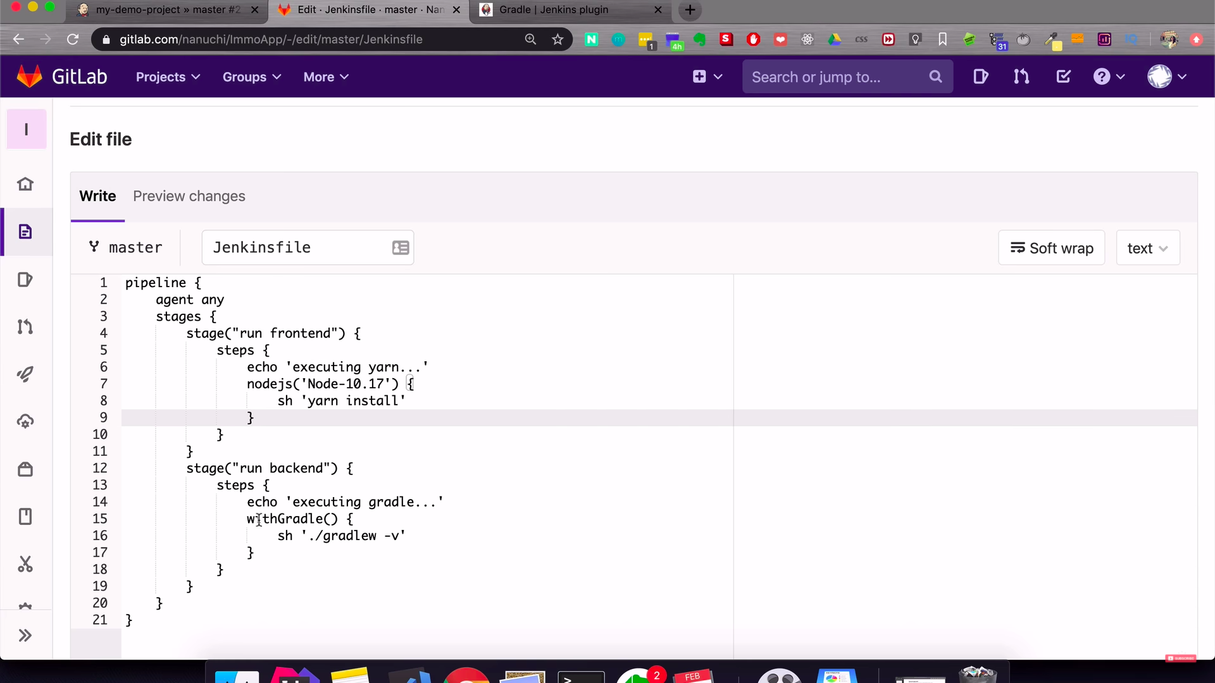

**What is JenkinsFile?**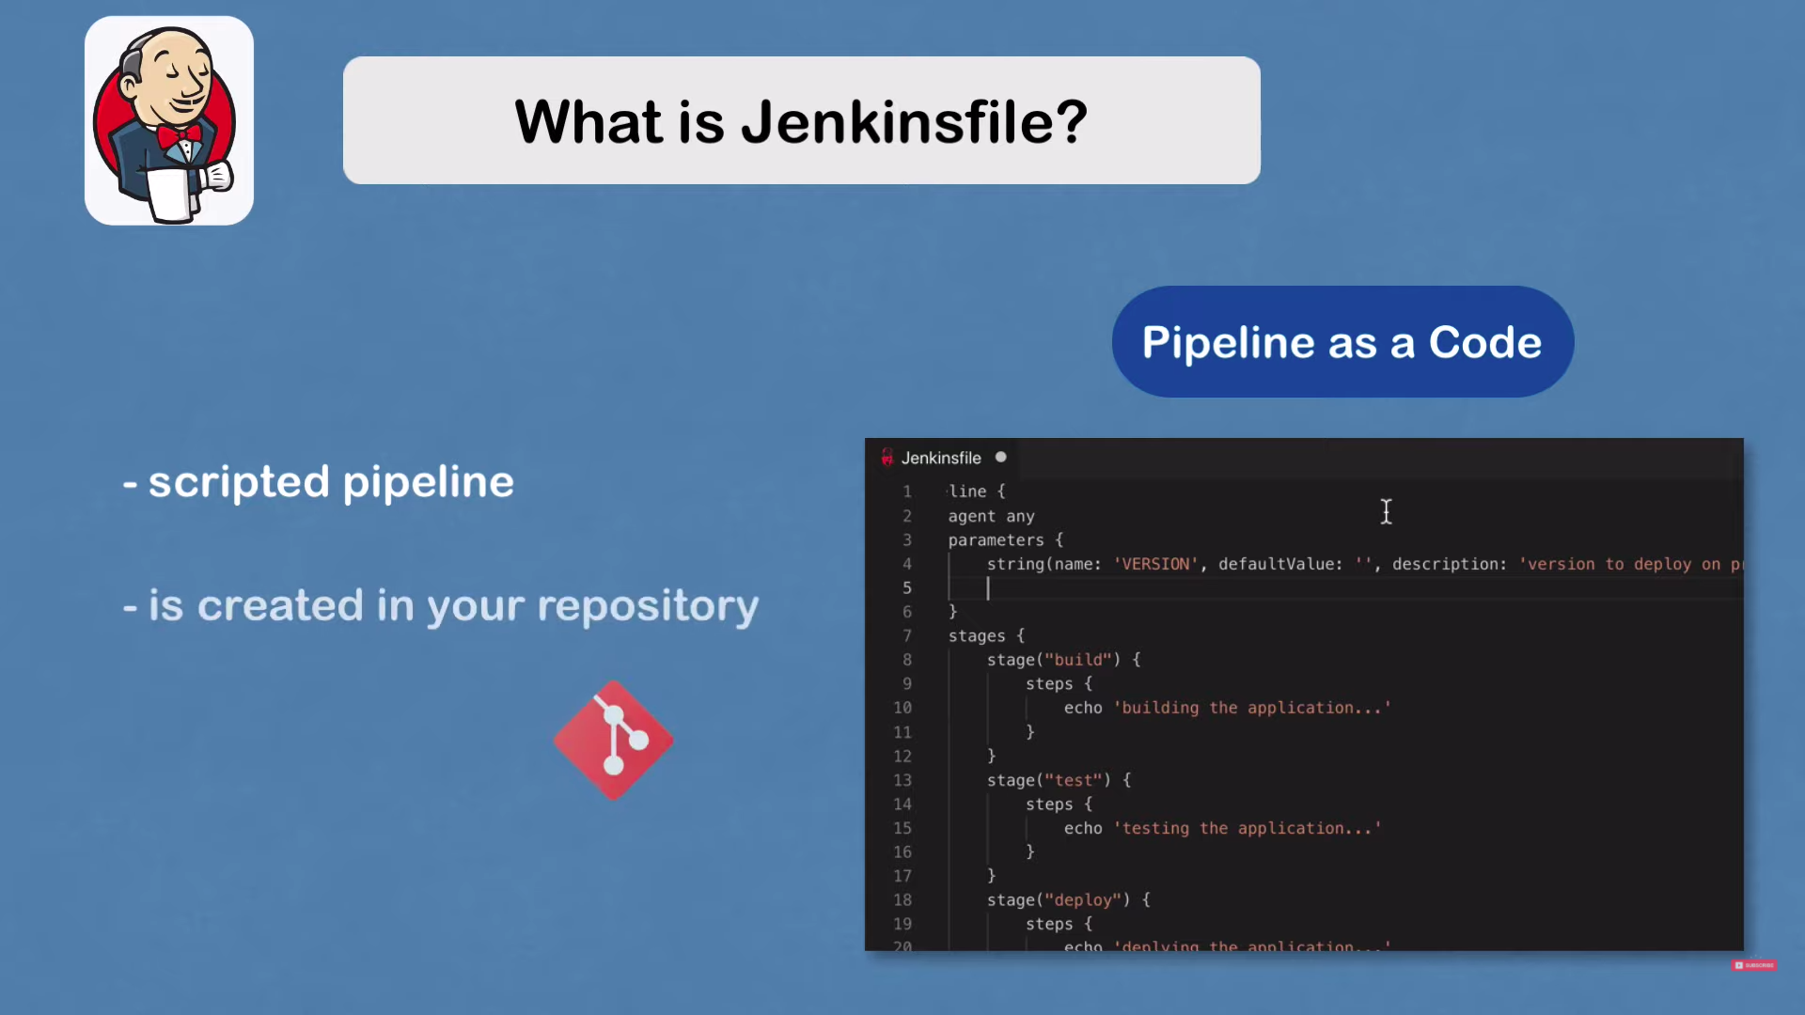

Conditions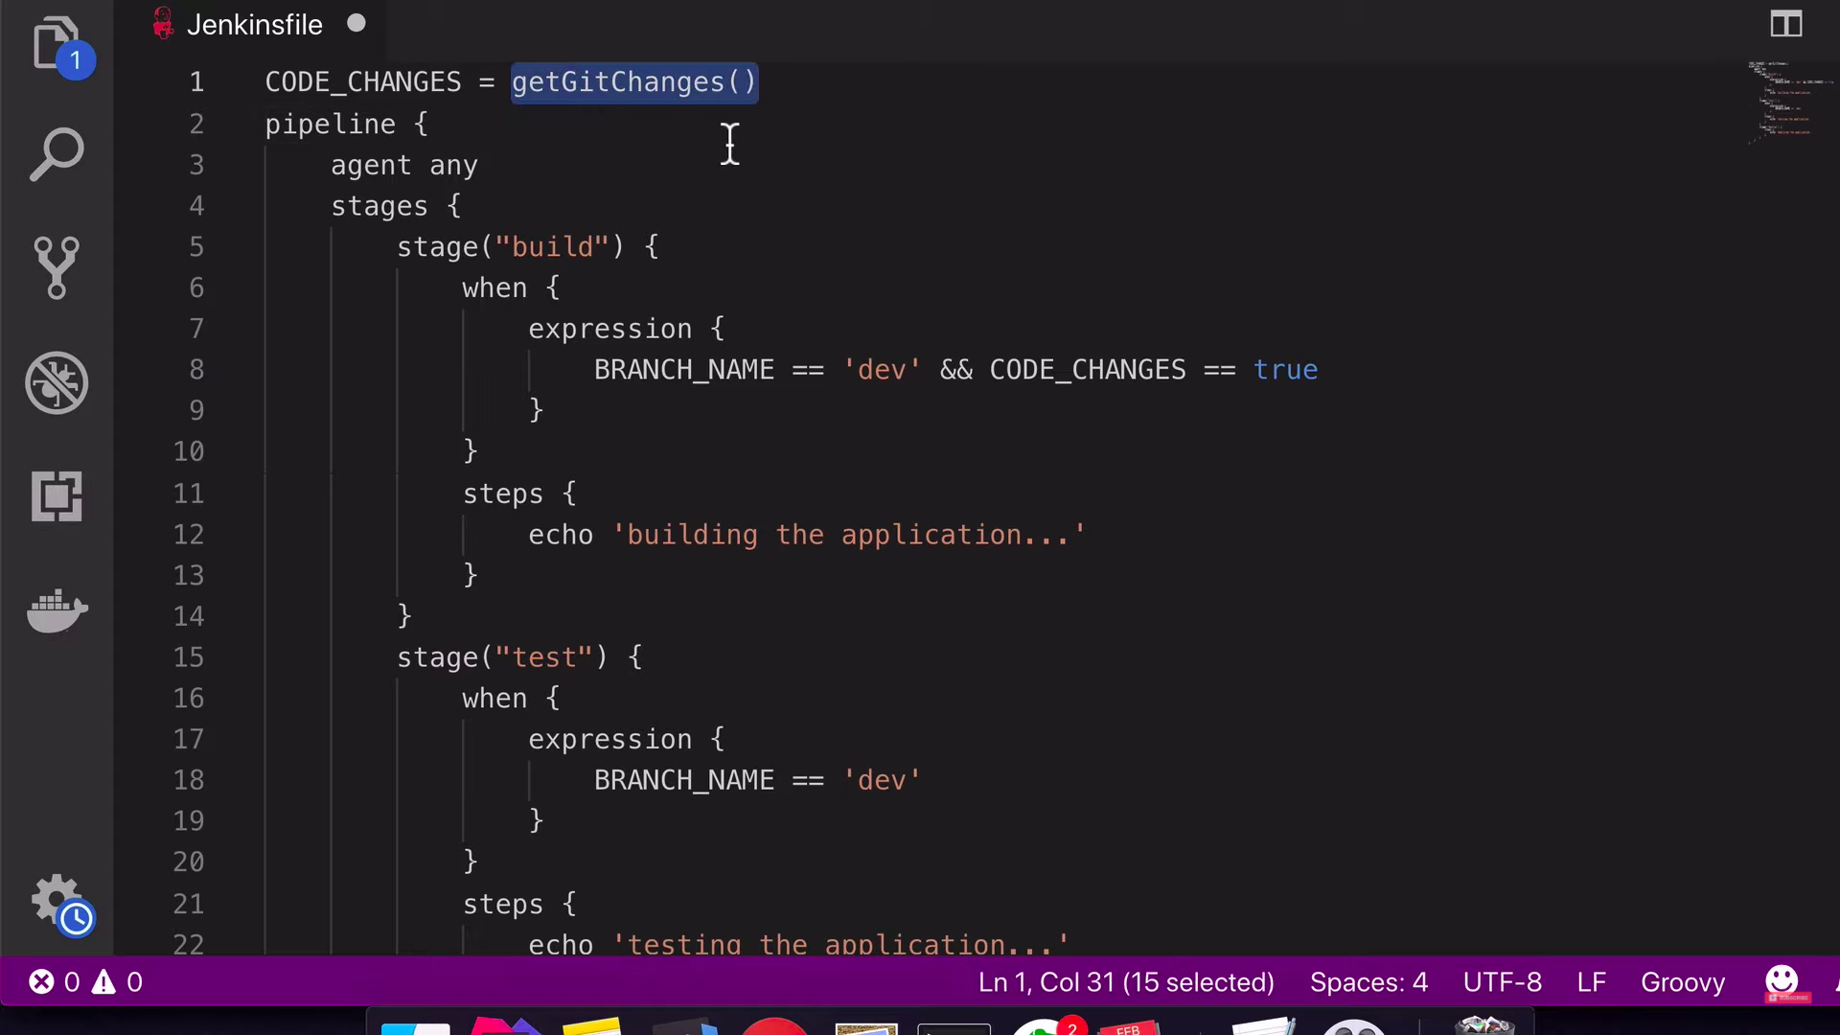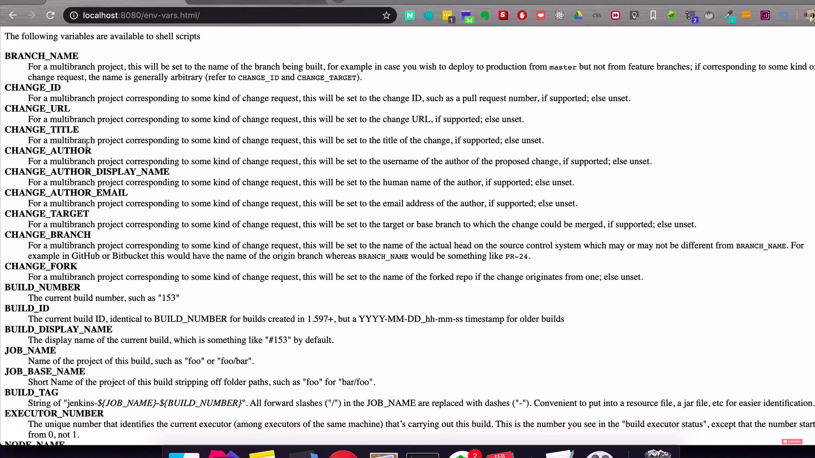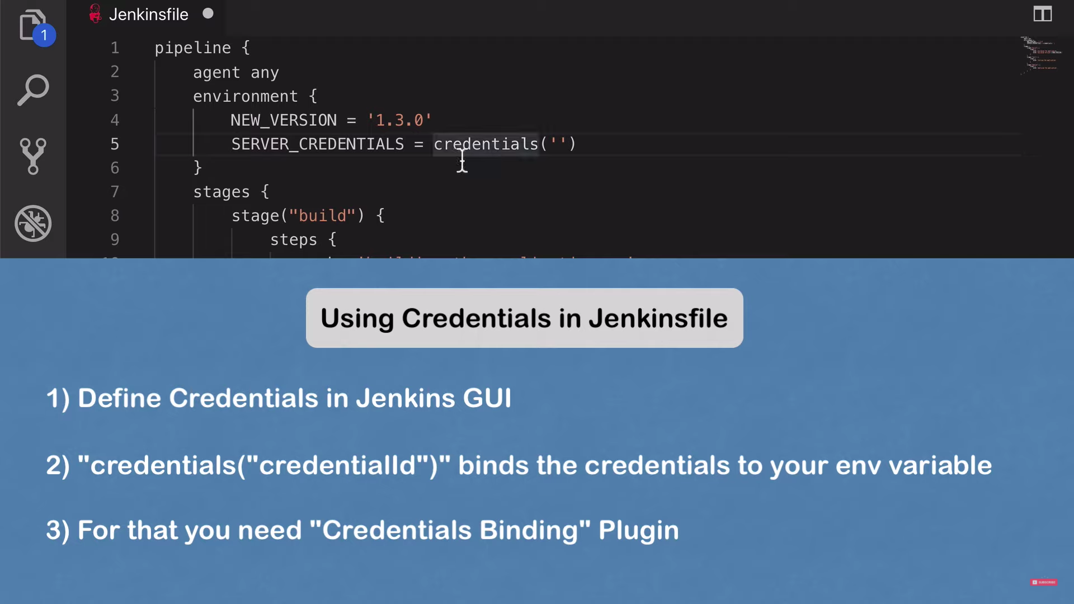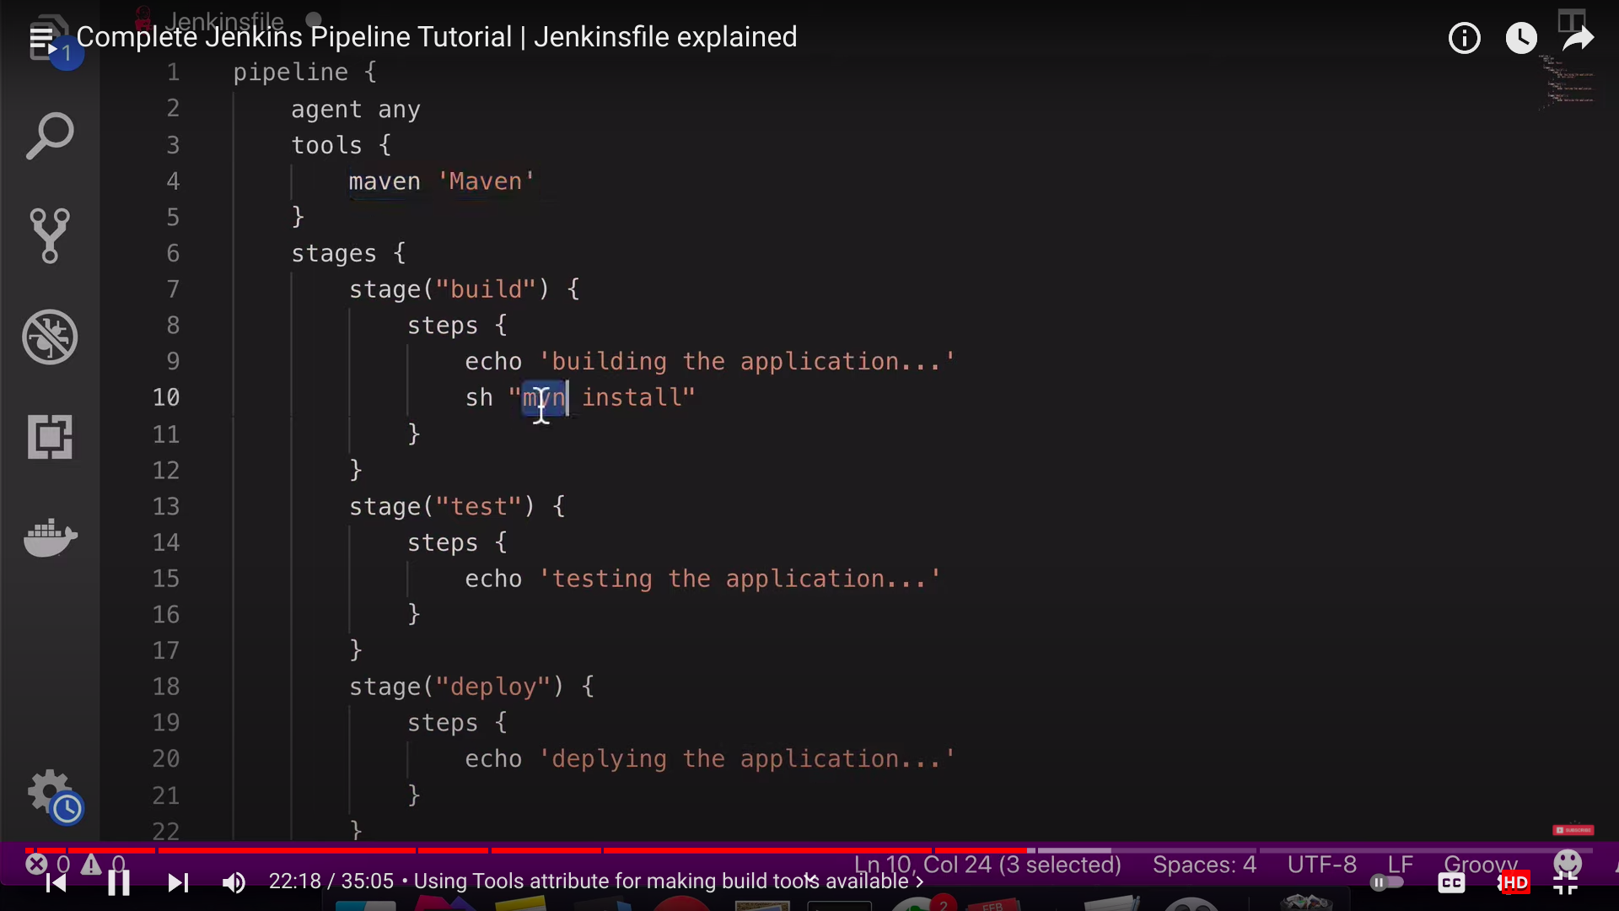

**Parameterized your build**

A build parameter **allows us to pass data into our Jenkins jobs**. Using build parameters, we can pass any data we want: git branch name, secret credentials, hostnames and ports, and so on. Any Jenkins job or pipeline can be parameterized.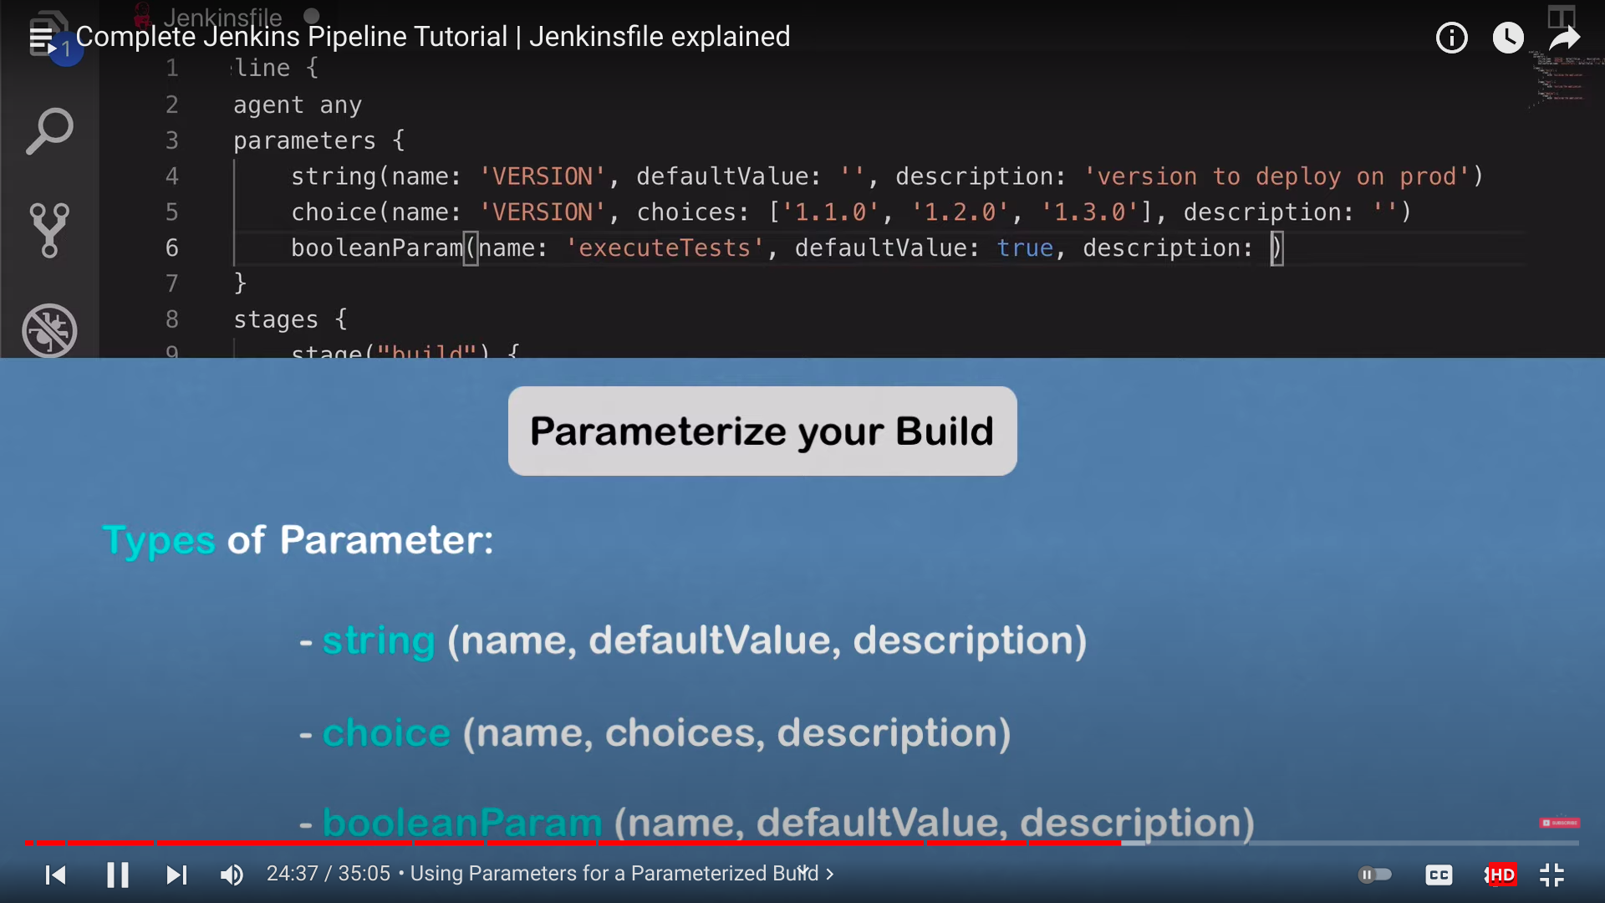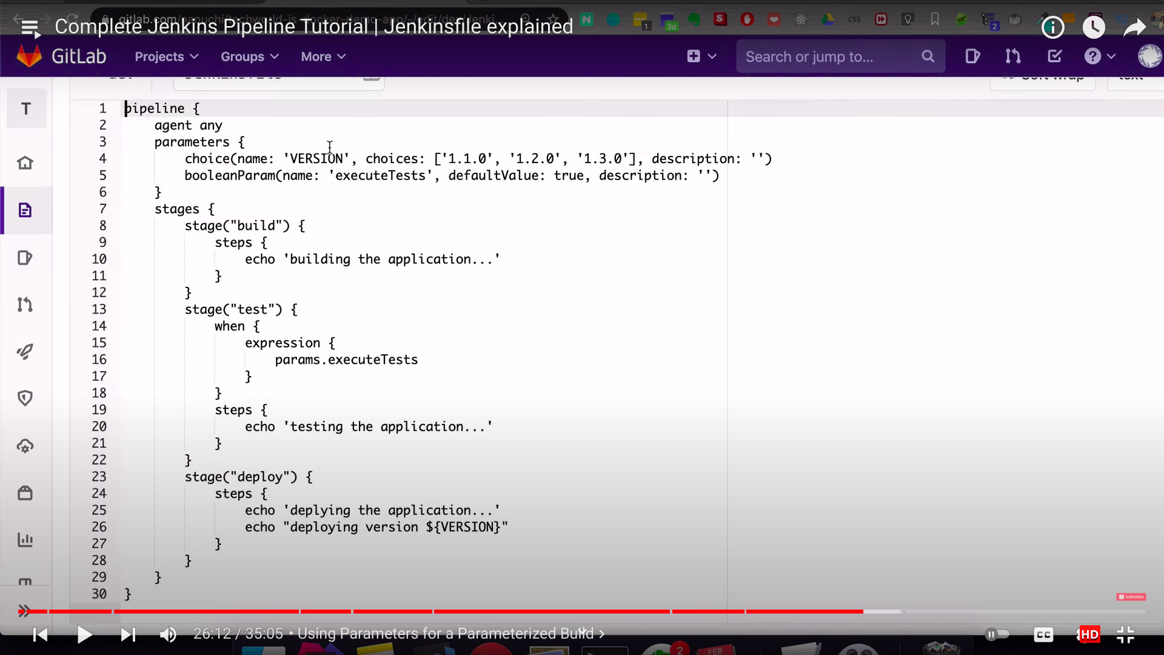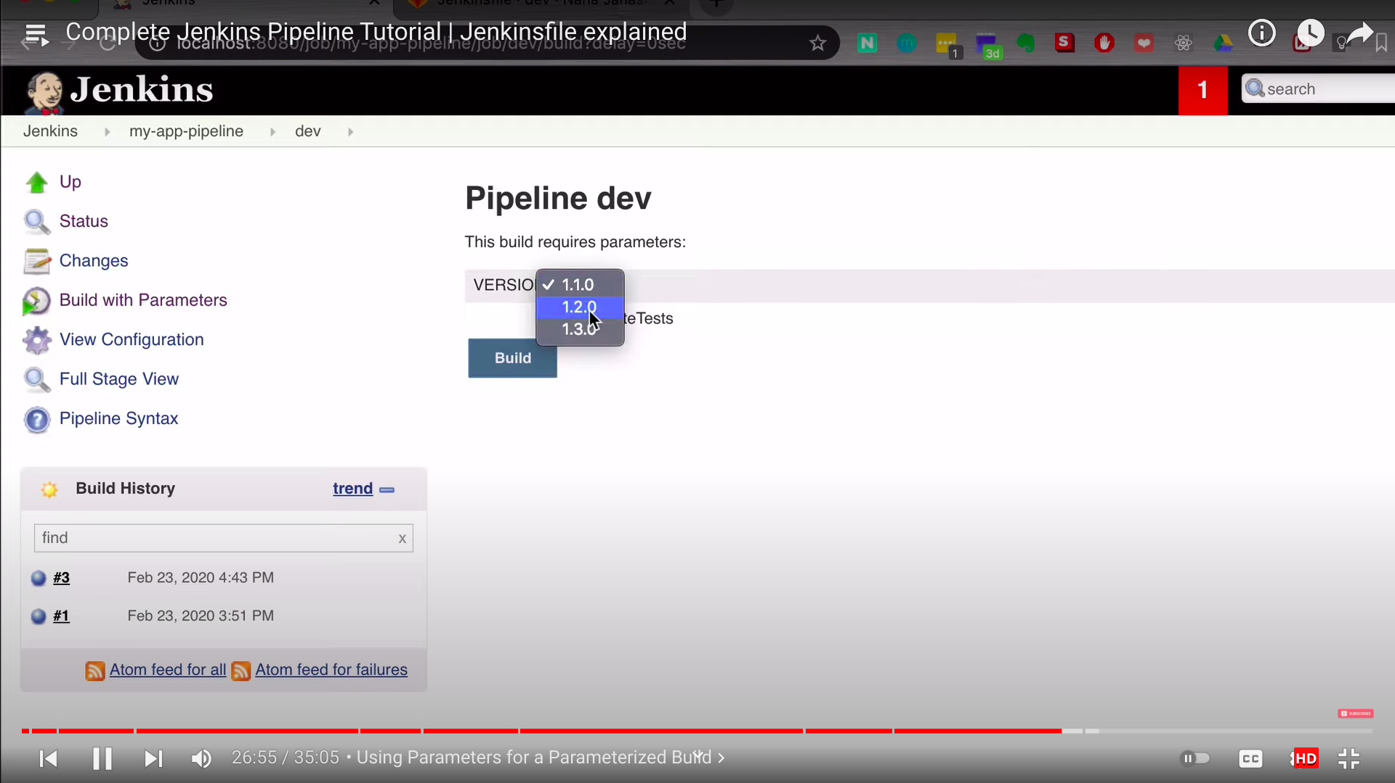

Environmental Variables.